0000.doc

EXAM MARKING KEY
CHEMISTRY—ANALYTIC MARKING KEY STAGE 2 PAPER

SECTION ONE

Question No | Answer
1. | C
2. | D
3. | C
4. | D
5. | C
6. | A
7. | A
8. | C
9. | A
10. | D
11. | C
12. | A
13. | D
14. | C
15. | A
16. | B
17. | A
18. | C
19. | D
20. | C
21. | B
22. | B
23. | D
24. | C
25. | A

SECTION TWO

Question 1 [6 marks]

For each of the following, describe briefly a test and an observation by which you could distinguish between the substances listed. You must indicate which of the two substances tested gives rise to the observation. No equations are necessary.

a) Sodium nitrate solution and sodium sulfate solution

Mark | Description
2 | Test: Add BaCl₂(aq) (or any other viable alternative)  Observation: A white precipitate will be produced in sodium sulfate solution (or matching observation to test).
1 | Student describes an appropriate test but not the appropriate observations.
0 | Question answered incorrectly or not at all.

b) Solid magnesium hydrogencarbonate and solid lead(II) sulphate

Mark | Description
2 | Test: Add dilute HCl(aq) (or appropriate test)  Observation: Bubbles of gas produced when added to hydrogencarbonate.
1 | Appropriate test described, but observations not correct.
0 | Question answered incorrectly or not at all.

c) Hexane and 1–hexene

Mark | Description
2 | Add bromine water or Br₂  Br₂ decolourises in 1–hexene.
1 | Appropriate test described but observations not correct.
0 | Question answered incorrectly or not at all.

Question 2 [2 marks]
Vitamin C is a water soluble vitamin that helps the body in fighting infection. Humans cannot produce this vitamin and it is best obtained from fruits and vegetables in their diet. The results of an analysis of vitamin C showed that it has an empirical formula of C₃H₄O₃ and an approximate formula mass of 180.
Use this information to determine the molecular formula of Vitamin C.

Mark | Description
2 | Calculates empirical mass and determines ratio to match molar mass
1 | Calculates empirical mass
0 | Question incorrectly answered or not attempted.

Empirical formula mass of C₃H₄O₃ = (3x 12.01) + (4x1.008) + (3x16)

= 88.06

Ratio Molecular formula = Formula mass
Empirical formula Empirical mass

= 180
88.06

= 2.04
Molecular formula is C₆H₈O₆
Question 3 [8 marks]

Complete the table below by identifying by name a substance found around the home that exhibits the bonding type indicated. Describe its use and the related property.

The answers must be within the unit focus and should not have examples such as sodium. The use and related property must match to be given a mark (each response is worth 1 mark).

Bonding type | Name | Use and related property  (The use must be related to the property)
Metallic | copper wire | good conductor of electricity—electrical conductivity  (conductor of heat, ductility, malleability hardness, lustre)
Covalent molecular | water  ethanol  butane | solvent—able to dissolve polar substances.  solvent—able to dissolve oil and grease.  fuel—produces energy on reaction with O₂.
Ionic | potassium nitrate | fertiliser—soluble source nitrates for plants.
Covalent network | graphite  silicon dioxide | lubricant—thin 2 dimensional plates  abrasive—hardness of material.

Question 4 [8 marks]

Ammonium sulfate can be produced using a two-step process that can be represented by the following reactions:

Step 1 2NH₃(aq) + CO₂(aq) + H₂O() → (NH₄)₂CO₃(aq)
Step 2 (NH₄)₂CO₃(aq) + CaSO₄(aq) → (NH₄)₂SO₄(aq) + CaCO₃(s)

- In step one, excess carbon dioxide gas is bubbled through 520.0 mL of a 0.225 mol L⁻¹ solution of ammonia.

2NH₃(aq) + CO₂(aq) + H₂O() → (NH₄)₂CO₃(aq)

Assuming the volume of the solution does not change, what will be the concentration of ammonium carbonate produced?

Mark | Description
5 | 0.112 mol L^{–1} (reasonable range of answer permitted)
4 | Either single calculation error or missing units and incorrect significant figures.
1 – 4 | Marks allocated as indicated below.
0 | Question answered incorrectly or not at all.

N(NH₃) = 0.520(0.225)
= 0.117 mol 1 mark

n[(NH₄)₂SO₄] = ½ n(NH₃)
= 0.0585 mol 2 marks

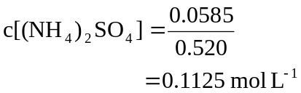 1 mark

- In step two, excess calcium sulfate solution is then added to the ammonium carbonate solution. What mass of ammonium sulfate will be produced?

(NH₄)₂CO₃(aq) + CaSO₄(aq) → (NH₄)₂SO₄(aq) + CaCO₃(s)

Mark | Description
3 | 5.62 g (reasonable range of answer permitted)
1 – 2 | Calculation errors
0 | Question answered incorrectly or not at all.

Molar mass [(NH₄)₂CO₃] = 96.09 g mol^{–1} 1 mark

Number of moles [(NH₄)₂CO₃)] = n[(NH₄)₂SO₄]
= 0.0585 mol 1 mark

Mass of (NH₄)₂CO₃ = 0.0585(96.09)
= 5.62 g 1 mark

Question 5 [4 marks]

(a) Write a half equation to represent the formation of sodium at the cathode.

Mark | Description
2 | Na⁺ + e– → Na
1 | One error in equation
0 | Question answered incorrectly or not at all.

(b) Write a half equation to represent the formation of bromine at the anode.

Mark | Description
2 | 2Br– → Br₂ + 2e–
1 | One error in equation
0 | Question answered incorrectly or not at all.

Question 6 [5 marks]

- Acetic acid in the form of vinegar is suitable for human consumption. Suggest reasons why 0.1 mol L^{–1} vinegar can be consumed, but other acids such as 0.1 mol L^{–1} hydrochloric and 0.05 mol L^{–1} sulfuric acids are not.

Mark | Description
3 | Vinegar is a dilute form of a weak acid and only partially ionised while HCl and H₂SO₄ are strong acids and are completely ionised.  [H⁺] is lowest in vinegar.
2 | Acetic acid is a weak acid while HCl and H₂SO₄ strong.
1 | Acetic acid is a weak acid.
0 | Question answered incorrectly or not at all.

- The most common deposit left in kettles is calcium carbonate. Write an equation to illustrate how acetic acid removes the calcium carbonate.

Mark | Description
2 | CaCO₃ + 2CH₃COOH → Ca²⁺ + 2CH₃COO– + CO₂ + H₂O
1 | CaCO₃ + 2CH₃COOH → Ca(CH₃COO)2 + CO₂ + H₂O
1 | One error (e.g. not balanced correctly).
0 | Question answered incorrectly or not at all.

Question 7 [4 marks]

A student was given a sample of butter, containing only saturated fats, and a polyunsaturated margarine. Both of these compounds have long hydrocarbon chains.

- What do the terms ‘saturated’ and ‘unsaturated’ mean in this context?

Mark | Description
2 | Saturation refers to the bonding in the hydrocarbon chain. Saturated compounds all have single covalent bonds in the hydrocarbon chain, while unsaturated compounds have at least one double bond in the hydrocarbon chain.
1 | The answer is in terms of the presence of double and single bonds but the location of the bonds is not mentioned.
0 | Question incorrectly answered or not attempted.

- Describe a simple chemical test that the student could use to determine which sample was the margarine. Include any relevant observations.

Mark | Description
2 | Describes an appropriate test, such as the decolourisation of iodine water or bromine water and includes correct observations.
1 | Describes the correct test, but the observations are not included or are incorrect.
0 | Question incorrectly answered or not attempted.

Question 8 [11 marks]

The reaction between aluminium metal and concentrated sodium hydroxide is often used to produce hydrogen gas to fill weather balloons. The reaction involved can be represented by the equation:

2Al(s) + 2OH–(aq) + 6H₂O() → 2[Al(OH)₄]–(aq) + 3H₂(g)

- 452 g of aluminium was added to excess concentrated sodium hydroxide solution. What volume of hydrogen gas will be produced at S.T.P.?

Mark | Description
5 | 562 L (reasonable range accepted)
1–4 | As per marking guide below
0 | Question answered incorrectly or not at all.
n(A) = 452
26.98

= 16.74 mol

n(H₂) = 3 (16.74)
2

= 25.11 mol
V(H₂) = 25.11(22.41) L
= 562.L

- As the weather balloon rises, the external temperature and pressure will decrease. Describe and explain the effects these changes will have on the volume of the balloon.

Mark | Description
6 | Pressure is a measure of the number of collisions per unit time with the walls of the balloon.  As pressure decreases (assuming constant temp) the volume of the balloon would increase as the number of collisions on the outside of the balloon decreases. Therefore the internal pressure will be higher than external and so the particles will ‘push’ the walls of the balloon out.  As the temperature decreases (assuming constant pressure) the volume decreases as the particles are moving slower and will not collide as frequently with the walls of the balloon.  Balloon’s volume would be influenced by both factors.
4–5 | Defines pressure and temperature.  As pressure decreases volume increases and as temperature decreases volume decreases.  Not explained in terms of particles.
1–3 | As pressure decreases volume increases and as temperature decreases volume decreases.
0 | Question answered incorrectly or not attempted.

Question 9 [8 marks]
Draw four isomers for this compound, including two geometric isomers of an alkene and one cycloalkane isomer. You must name each isomer using IUPAC nomenclature.

Mark | Description
8 | All four isomers, including the first three prescribed structures, correctly named and drawn.
7 | All four isomers, including the first three prescribed structures and names, with one error.
5–6 | The answer has four correctly drawn and named isomers but there is one of the prescribed isomer types missing.
2–4 | Correctly drawn isomers, but not named.
0–1 | Question incorrectly answered or not attempted.

Structure | Name
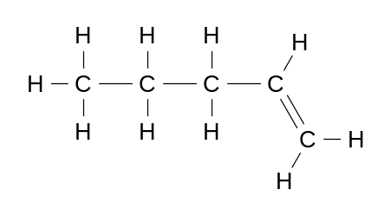 | pent–1–ene
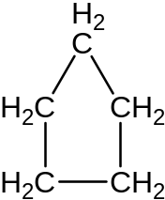 | cyclopentane
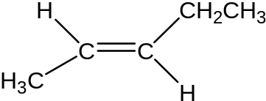 | trans–2–pentene

Structure | Name
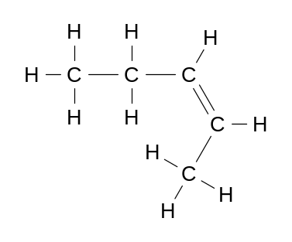 | cis–2–pentene
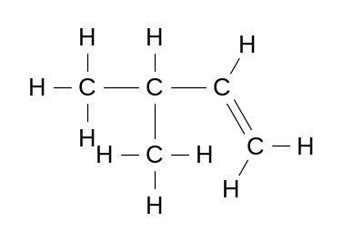 | 3–methyl–1–butene

Question 10 [4 marks]

An unknown molecular compound consists of carbon, hydrogen and oxygen. Burning 5.27 g of the unknown compound produced 7.72 g of carbon dioxide and 3.16 g of water. Using this information determine the empirical formula (C_{x}H_{y} O_{z} ) of the unknown compound.

Mark | Description
4 | Correctly determines empirical formula CH₂O
3 | Calculates an empirical formula CHO because the number of moles H₂O was not doubled to get the correct number of moles of H atoms.
2 | Calculates the number of moles of CO₂ and H₂O
0 | Question incorrectly answered or not attempted.

Nº moles CO₂ = 7.72
44.01 1 mark

= 0.1754

Moles of C atoms = 0.1754 moles

Mass of Carbon = 12.01 x 0.1754

= 2.107g

Moles of H₂O = 3.16
18.016

= 0.1754

Moles H atoms = 2 x 0.1754 = 0.3508 moles
Mass of H atoms = 0.3508 x 1.008 = 0.3536 g 1 mark

Mass of O atoms = [mass of compound – (mass of C + mass of H)]

= [ 5.27 – (2.107 + 0.3536)]

= 2.809 g 1 mark

Mole of O atoms = 2.809 = 0.1756 moles
16

C H O

Moles 0.1754 0.3508 0.1756

Mole ratio 1 2 1

Empirical Formula CH₂O 1 mark

Question 11 [10 marks]

Hydrogen fluoride is often used to purify quartz, a mineral which is composed of SiO₂. It also has the ability to etch and corrode glass containing silicon dioxide. As a result, hydrogen fluoride cannot be stored in glass bottles. It is usually stored in plastic or metal containers.

The reaction between hydrogen fluoride and the silica in glass can be represented by the following equation:
4HF() + SiO₂(s) → SiF₄(g) + 2H₂O()

If 3.44 g of silicon dioxide was added to 24.5 g of liquid hydrogen fluoride, then:

- Determine the limiting reagent in the reaction. Justify your decision.

Mark | Description
4 | SiO₂ correctly identified as LR with appropriate working
2 – 3 | Calculation errors
1 | LR stated without working
0 | Question answered incorrectly or not at all.
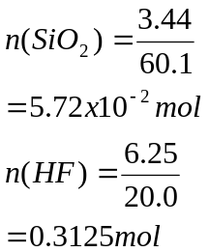 2 marks

1 mole of SiO₂ requires 4 moles of HF
5.73 x 10^{–2} mol of SiO₂ requires 4(5.73 x 10^{–2}) = 0.2292 mol 1 mark

Number of moles of HF required is less than number of moles available,
Therefore SiO₂ is LR. 1 mark

- What mass of silicon tetrafluoride was produced?

Mark | Description
3 | 5.96 g
2 | 8.12 g if HF identified as LR
1 | Calculation error
0 | Question answered incorrectly or not at all.

n(SiF₄) = n(SiO₂)
= 5.73 x 10^{–2} mol 1 mark

m(SiF₄) = 5.73 x 10^{–2}(104) 1 mark
= 5.96 g

- What is the mass of the excess reagent after the reaction is complete?

Mark | Description
3 | 1.67 g (no answer possible if student chooses wrong LR)
1–2 | Calculation errors
0 | Question answered incorrectly or not at all.

n(HF) = 0.3125 – 0.2292
= 8.33 x 10^{–2} mol 2 marks

m(HF) = 8.33 x 10^{–2} (20)
= 1.67 g 1 mark

Question 12 [10 marks]

From your knowledge of the solubility rules and reactions, describe what tests you could use to determine the identity of the salt. You must include any relevant observations and equations for each test in your answer. You may wish to use flowcharts, tables etc. to represent your answer. The third unknown can be determined by the process of elimination.

Example of flowchart

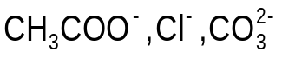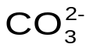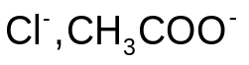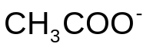
Dissolve in water and add dilute HC
Bubbles of gas
Add
or valid
alternative to give a ppt.
No precipitate
Precipitate

Mark | Description
10 | All steps correct and the flow chart represented clearly.
1–9 | Marks allocated as indicated above.
0 | Question not answered correctly or not attempted.

Question 13 [16 marks]

- Write an equation to represent the reaction between nitrogen and hydrogen to produce ammonia, including a representation of heat of reaction.

Mark | Description
2 | N₂(g) + 3H₂(g) → 2NH₃(g)
1 | Incorrectly balanced
0 | Question answered incorrectly or not at all.

- It is important that commercial chemical processes occur as rapidly as possible at a reasonable cost. Describe and explain in terms of your understanding of collision theory what methods could be used to speed up the rate of reaction between nitrogen and hydrogen. You must include diagrams/graphs in your answer where appropriate.

Mark | Description
9–10 | Increasing concentration (or partial pressures) of reactants—more particles per unit volume increases the chance of collision, therefore the rate of reaction increases (% of successful collisions does not change). N₂ can be readily increased as it is the cheapest component (as it is isolated from air).  Increase in temperature—particles move faster therefore there are more collisions per unit time; more particles have sufficient energy to react, therefore there are more successful collisions. The second factor is more significant. Diagram/graph shows two kinetic energy distributions (at a higher temperature more particles have energy greater than the activation energy).  Using a catalyst provides an alternative reaction pathway with a lower activation energy, therefore more particles have sufficient energy to react. Diagram shows two reaction pathways, the catalysed pathway has a lower activation energy barrier.
7–8 | Factors described appropriately but not linked explicitly to ammonia reaction OR  Diagrams not included in answer.
3–6 | All factors listed, but not all correctly explained in terms of collision theory
1–2 | Factors listed but not correctly explained in terms of collision theory
0 | Question answered incorrectly or not at all.

- Ammonia can be injected directly into the soil to act as a fertiliser, but more often it is converted to other forms, such as ammonium nitrate, ammonium sulfate and ammonium hydrogenphosphate.

Ammonium sulfate can be produced by addition of ammonia to sulfuric acid.

Write an equation to represent the formation of ammonium sulfate.

Mark | Description
2 | 2NH₃ + H₂SO₄ → (NH₄)₂SO₄
1 | Equation not correctly balanced.
0 | Question answered incorrectly or not at all.

- Draw an electron dot structure for ammonia.

Mark | Description
2 | Correct structure as below.
1 | Non–bonding electrons missing or one error.
0 | Question answered incorrectly or not at all.

N
H
··
:
H
:
H
··

Question 14 [13 marks]

A student tested the conductivity of solutions of:
- sodium hydroxide
- acetic acid
- sugar.

- Draw a labelled diagram of the apparatus you would use to test the conductivity of the solutions.

Mark | Description
4 | Fully labelled diagram showing all necessary components.
1–3 | Suitable diagram without all of the labels or components.
0 | Question answered incorrectly or not at all.

test solution
battery or powerpack
ammeter
or globe
switch
inert electrodes
(graphite)

- Explain how an electrolyte is able to conduct an electric current.

Mark | Description
2 | The solution contains mobile hydrated ions that move through the solution towards the electrodes
1 | The solution contains ions
0 | Electrons move though the solution or answered incorrectly or not at all.

- Explain the observations that have been recorded in the table. Your answer should include equations that explain the differences in conductivity where appropriate.

Mark | Description
5–7 | NaOH is a strong electrolyte and the NaOH dissociates.  Equation: NaOH → Na⁺ + OH–  CH₃COOH is a weak electrolyte, therefore only some of the molecules ionise when added to water.  Equation: CH₃COOH + H₂O CH₃COO– + H₃O⁺  For conductivity to occur there must be mobile charges (or ions) present.  Conductivity is directly proportional to the number of ions present in solution. Strong electrolytes will produce a greater number of ions in solution than weak electrolytes for the same concentration. Therefore the concentration of ions in the NaOH solutions will be higher than the CH₃COOH for the same concentration of solute.  Sugar is a non–electrolyte. It does not produce ions when dissolved in water. As there are no mobile charged particles, the solution does not conduct electricity.
3–5 | Explanation similar to above but no equations included.
1–2 | Answer addresses conductivity of strong electrolytes and non–electrolyte adequately but not acetic acid.  Some correct points made, but not explained fully.
1 | Makes one or two correct points.
0 | Question answered incorrectly or not attempted.

Question 15 [8 marks]

Thermal conductivity is a measure of a substance’s ability to conduct heat.

A company wishes to develop a new frying pan with a non–stick surface. They investigate the properties of a number of substances which are given in the table below. From this information and your understanding of bonding and structure, identify the materials you would use to make the base and handle of the frying pan. Explain your choices in detail.

Mark | Description
7–8 | Answer includes materials chosen, the properties that were used to make the choice and the structure of the materials that explains the properties. For full marks there should be reference to the table of information and the answer should be constructed in a clear and coherent manner. Students may also indicate why materials were inappropriate, but this is not required for full marks.
5–6 | Answer includes materials chosen and some linking between properties and choice. The explanations should be accurate.
3–4 | Answer includes materials chosen and some linking between properties and choice. The explanations have some accuracies and some deficiencies.
1–2 | Answer includes materials chosen and one or two properties with no appropriate linking to use
0 | Question answered incorrectly or not at all

Question 16 [23 marks]

- Explain in terms of the equations shown why the spray released from the gland of the bombardier beetle is hot.

Mark | Description
2 | Reactions are exothermic, heat energy is produced and so temperature rises
1 | Reaction is exothermic
0 | Question answered incorrectly or not at all.

- Refer to equation 2 to explain why the spray released from the gland of the bombardier beetle sprays out of the back of the beetle very rapidly.

Mark
2 | Oxygen gas is produced rapidly and pressure builds up (or gas is forced out)
1 | Oxygen is produced OR gas is forced out (or similar)
0 | Question answered incorrectly or not at all.

- A student investigates the effect of the concentration of hydrogen peroxide on the rate of the decomposition reaction (equation 2) in the laboratory. She adds a solid catalyst to hydrogen peroxide solution and measures the rate at which oxygen is given off.

- List TWO variables you would expect to control in this experiment.

Mark | Description
2 | States two appropriate variables, including:  - Mass of catalyst  - Volume of hydrogen peroxide  - Temperature of system
1 | One appropriate variable given
0 | Question answered incorrectly or not at all.

- List ONE variable you have to measure and ONE other variable that you could measure to determine the rate of reaction.

Mark | Description
2 | States time and one of two appropriate variables:  - Loss of mass  - Volume of oxygen produced
1 | States two variables but does not include time
0 | Question answered incorrectly or not at all.

- Suggest an appropriate method for this experiment. You may include a diagram in your answer.

Mark | Description
5 | Describes a method for measuring the dependant and independent variables and controlling other variables. An appropriate method or labelled diagram for collecting gas or measuring mass loss.
4 | The method is appropriate for measuring the dependant and independent variables but little or no mention of control of other variables. An appropriate method or labelled diagram for collecting gas or measuring mass loss.
3 | The method is appropriate for measuring the dependant and independent variables but other variables are not mentioned or the method for the collection of the gas evolved or the mass loss is not appropriate.
2 | The method identifies measurable variables but the method described is flawed and is not likely to establish a cause and effect relationship.
1 | Some apparatus shown correctly.
0 | Question answered incorrectly or not at all.

- Plot the data on the graph.
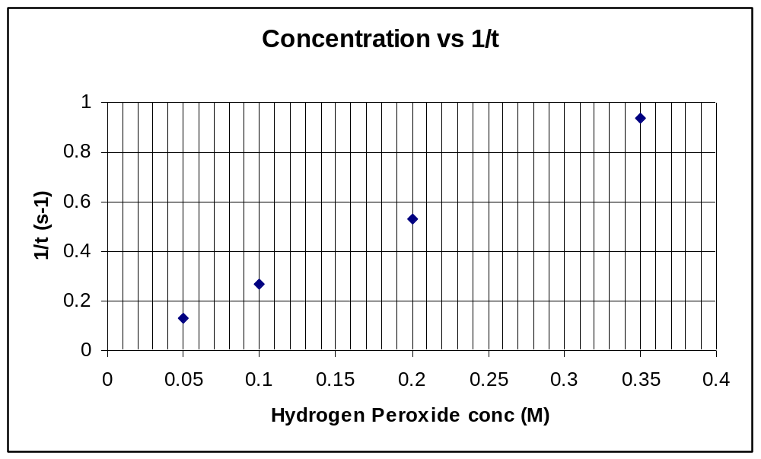
mol L^{–1}

Mark | Description
5 | All five categories given:  - All axes labelled correctly  - Correct units on axes titles  - Points plotted correctly  - Line of best fit  - Graph title
4 | 4 of the five categories given, including line of best fit
3 | 3 of the five categories given, but no line of best fit
2 | 2 of the five categories given
1 | 1 of the five categories given
0 | Question answered incorrectly or not at all.

- Based on the data, write a conclusion for this experiment.

Mark | Description
2 | As the concentration of hydrogen peroxide increases the rate of reaction increases.  There is a direct relationship between the concentration of hydrogen peroxide and the rate of reaction
1 | As the concentration of hydrogen peroxide increases the rate of reaction increases.  OR  There is a direct relationship between the concentration of hydrogen peroxide and the rate of reaction

- Identify THREE potential sources of error in the above experiment.

Mark | Description
3 | Three appropriate potential sources of error stated:  - Beginning timing at the same point each time.  - Gas collection (not allowing gas to escape)  - Air is collected with oxygen
2 | Two appropriate sources of error stated
1 | One appropriate source of error stated
0 | Question answered incorrectly or not at all.

ACKNOWLEDGEMENTS

SECTION TWO

Question 16 http://www.ocr.org.uk/Data/publications/specimen_assessment_materials/cquar tetOCRTempFileY3R8iY3TBH.pdf

Published by the Curriculum Council of Western Australia
27 Walters Drive
OSBORNE PARK WA 6017

CHEMISTRY
Sample external written examination
Stage 2
Mapping questions to content

Course  content | Macroscopic properties of matter | Atomic structure and bonding | Chemical reactions | Acids and bases in aqueous solutions | Oxidation and reduction | Organic Chemistry | Applied  chemistry
Section 1 – Multiple choice
Question
1 |  |  |  |  |  |  | ✓
2 | ✓
3 | ✓
4 | ✓
5 | ✓
6 |  |  | ✓
7 |  | ✓
8 |  | ✓
9 |  | ✓
10 |  | ✓
11 |  |  | ✓
12 |  |  | ✓
13 |  |  | ✓
14 |  | ✓
15 |  |  |  | ✓
16 |  |  |  | ✓
17 |  |  |  | ✓
18 |  |  |  | ✓
19 |  |  |  | ✓
20 |  |  |  |  | ✓
21 |  |  |  |  | ✓
22 |  |  |  |  | ✓
23 |  |  |  |  |  | ✓
24 |  |  |  |  |  | ✓
25 |  |  |  |  |  | ✓
Section 2
1 |  |  | ✓
2 |  |  | ✓
3 |  | ✓
4 |  |  | ✓
5 |  |  |  |  | ✓
6 |  |  |  | ✓ |  |  | ✓
7 |  |  |  |  |  | ✓
8 | ✓ |  | ✓
9 |  |  |  |  |  | ✓
10 |  |  | ✓
11 |  |  | ✓
12 | ✓ |  | ✓
13 |  |  | ✓
14 | ✓
15 | ✓ | ✓
16 |  |  | ✓ |  |  |  | ✓

